


The information for the ICL Open Access Book Series

Progress in Landslide Research and Technology (P-LRT)
The founding issues (Volume 1, Issue 1 and Issue 2) of the ICL Open Access Book Series “P-LRT” were published as the contribution to the Kyoto Landslide Commitment 2020 for global promotion of understanding and reducing landslide disaster risk. Volume 2, Issue 1 and Issue 2 were published in December 2023. Volume 3, Issue 1 and Volume 3, Issue 2 were published in June and December 2024. Volume 4, Issue 1 was published in September 2025 and Volume 4, Issue 2 will be published by the beginning of 2026. P-LRT is now indexed in SCOPUS.

Progress in Landslide Research and Technology, Volume 1 Issue 1, 2022 | SpringerLink 228,000 Access
Progress in Landslide Research and Technology, Volume 1 Issue 2, 2022 | SpringerLink 203,000 Access Progress in Landslide Research and Technology, Volume 2 Issue 1, 2023 | SpringerLink 66,000 Access Progress in Landslide Research and Technology, Volume 2 Issue 2, 2023 | SpringerLink 125,000 Access Progress in Landslide Research and Technology, Volume 3 Issue 1, 2024 | SpringerLink 75,000 Access
Progress in Landslide Research and Technology, Volume 3 Issue 2, 2024 | SpringerLink 75,000 Access
Progress in Landslide Research and Technology, Volume 4 Issue 1, 2024 | SpringerLink 8408 Access

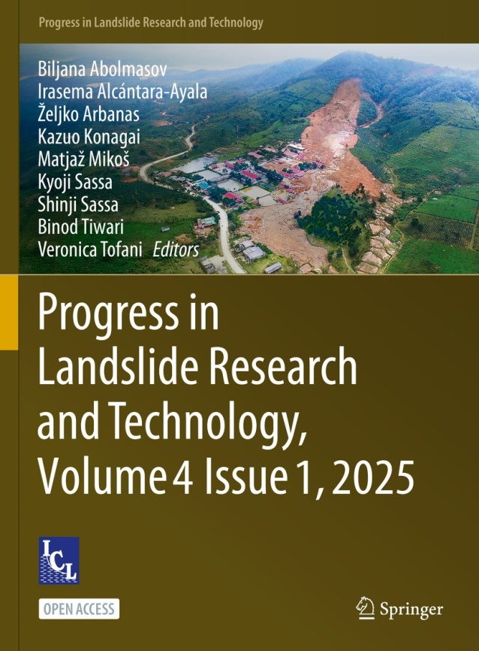
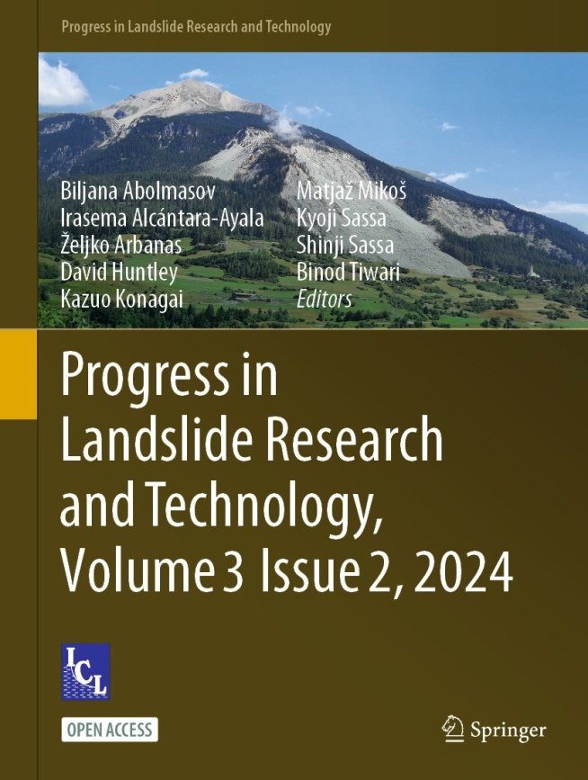



https://www.springer.com/series/16796




Book Processing Charge (BPC) will be charged after the acceptance and the page proof by Springer Nature. Springer Nature will edit each article depending on the quality of figures and photos. The printed page number will be different from the manuscript submitted by the authors. BPC is charged by the page number of the printed page of each article. The BPC is shown in the table below.
Types of Authors | BPC: up to 20 pages | BPC: additional pages
Regular (Non ICL members) | 50 USD/page | 40 USD/page
Regular (Non ICL members)  for a second paper within one year | 25 USD/page | 40 USD/page
ICL members: ICL Full members and  KLC Official promoters | 0 USD/page | 40 USD/page
ICL members: ICL Associates, ICL Supporters  and Working editors for P-LRT | 25 USD/page | 40 USD/page

The reduced BPC for ICL members: one or two articles (total pages up to 20) for one year.

Application form for an article in Vol.5, No.2 of P-LRT
Please fill and return to the KLC2020 Secretariat <klc2020@landslides.org > by 15 January 2026
Corresponding author
Office
E-mail
Title of the article
Planned Category  (Please select one)  Planned Page number  (Please write) | Planned Category  - Original articles  - Review articles  - ICL Landslide Lessons  - IPL/WCoE/Kyoto Commitment  - Teaching tools with online extras  - Technical note & Case studies  - World Landslide Reports (No BPC) | Planned Page number

