**Title of Contribution for Progress in Landslide Research and Technology Book Series (do not exceed 100 characters including spaces)**

Firstname Firstsurname, Secondname Secondsurname

|  |
| --- |
| Abstract |

This is an example text template for the full paper submission to the Progress in Landslide Research and Technology book series. The book series publishes original articles for practice. Contributed articles align with one of five categories: Original articles, Review articles, Case studies, IPL/WCoE/Network activities and Teaching tools with extras online (PPT, Video). The Abstract should be concise and self-contained, clearly stating main conclusions of the paper. The length should be of minimum 150 words, and within 300 words. The style to be used, according to the Template Style List, is the Normal Style with justification. At the end of the abstract text a list of keywords (minimum: 3 maximum: 7) should be added as shown in this template.

The paper size should be set to size (210 mm × 279 mm). Please submit both MS-Word and pdf files.

|  |
| --- |
| Keywords |

keyword1, keyword2, keyword3…

|  |
| --- |
| General body of the manuscript |

The main text of the paper should be formatted using Normal Style according to the Template Style List. The first paragraph of each Section should not have right indentation whilst following paragraphs should, as in the following.

Fistname Fist urname

Peking University, Department of Sciences, Beijing 100082, China

e-mail: [second@pku.ac.cn](mailto:second@pku.ac.cn)

Secondname Secondsurname

Peking University, Department of Sciences, Beijing 100082, China

e-mail: second@pku.ac.cn

Thirdname Third surname

Peking University, Department of Sciences, Beijing 100082, China

e-mail: second@pku.ac.cn

Fourth name Fourthcsurname

Peking University, Department of Sciences, Beijing 100082, China

e-mail: second@pku.ac.cn

Left indentation is of 5 mm (as per Template Style Normal). The Normal style of text is based on the Times New Roman font, available within Microsoft Word software in all recent releases, size 10. Line spacing is 12.5pt. The page format must be strictly respected as per Template Page Format.

|  |
| --- |
| Sections of the manuscript |

## How to start?

Copy the template file, Templatebook-Fullpaper.docx, to the template directory. This directory can be found by selecting the Tools menu, Options and then the File Locations. When the Word program is started, open the File menu and choose New. Select Templates, On my computer, and then the template, Templatebook- Fullpaper.docx.

Please rename the document before you start writing your paper.

## Figures and figure captions

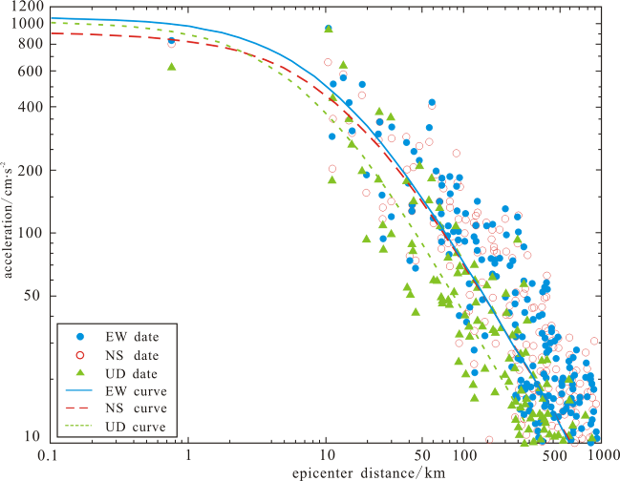

Fig. 1 Example of half page figure. Captions which are 2 or more rows long must be justified. Shorter caption must be column-centred. Please ensure to select the style “Figure Caption” and to place caption below figure. Figures should be cited in text using the short: “Fig.”.

Figures are allowed either in greyscale or in colour. It is possible to insert column-wide figures (half-page width) with maximum width of 85 mm and double-column- wide figures as well with a max allowed dimension of 174 mm. In any case, the max height is 230mm. Figure should be directly attached within the document at the right place using preferentially the “insert -> image -> from file” option of Microsoft Word using a recommended resolution of 400 dpi for greyscale images and of 300 dpi for colour images. TIFF format is recommended.

The following is an example of column-wide figure. The figure line (the line of text in which the figure has to be placed) should be formatted choosing the appropriate Style “Figure” from the Template Style List. This will ensure proper distancing between figure and surrounding text. However, authors are free to add one or two empty rows of normal text to adjust formatting and visual appearance.

|  |
| --- |
| Title, authors, affiliations and other issues |

## Title and authors

The paper should start with the title section which has a

special single-column formatting (see top of first page). Please make sure to maintain section separation to ensure proper column formatting of the document. In case you inadvertently delete the section break, insert a new one on top of the beginning of manuscript main body using Microsoft Word option “insert -> break -> section break -> continuous”.

Author’s names should precede paper title as in the example above. Please use style “Authors” for this part of paper.

The title should follow, according to the ICL journal “Landslides” style, the author’s names.

Finally, Affiliations conclude the first section of the paper, according to the style “Affiliation” in the Style List of paper Template. Each affiliation must be preceded by the relevant number between parentheses as in the example at the top of this file. Each affiliation must be placed on a separate line, using the following order:

Department/Branch/Office, Institution/University, Address, Country. For the affiliation of the corresponding author also the following information must be included: email and/or telephone number.

Each author should also define a short “running” author names and title to be used in the right of the even pages and in the left of the odd page headings, respectively (see example above in the page heading where the Template has the sentences “F. Author, S. Author, T. Author” and “Short Running Title of Contribution”). The running title should be limited to a maximum of 20 characters, blank spaces included. The page headings have a specific style “Page heading” to be used.

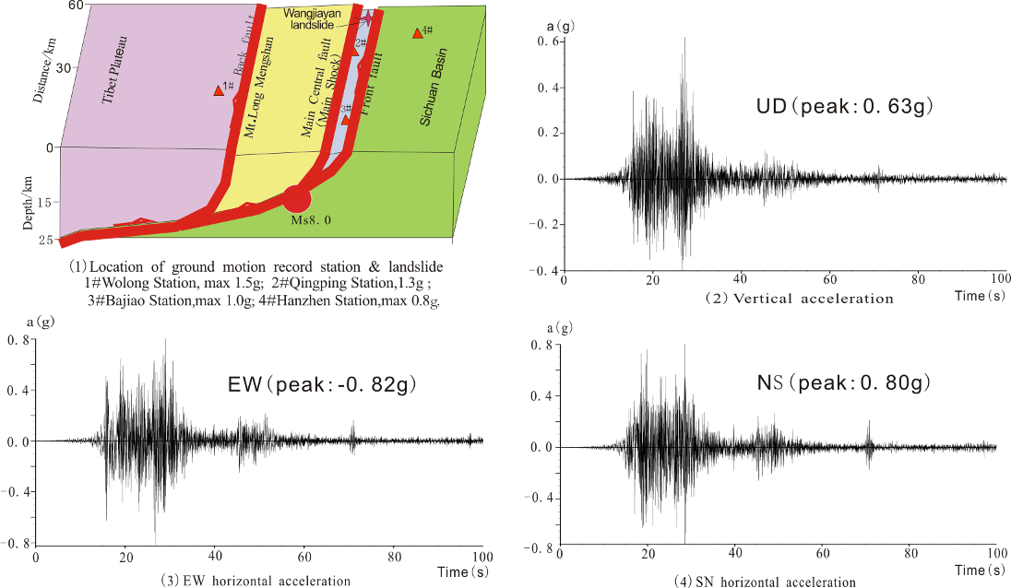

Fig. 2 Example of two-column figure. In case the caption of the figure is only one row, it must be center

## Maths and formulas

All mathematical notations should be kept outside normal text paragraphs with the exception of single (or very simple combination of) symbols. An example of use of in-text symbols is this: β is defined as the slope angle in degrees. More complex expressions should be placed under the style “Equation” and inserted in the manuscript as equation objects using the proper Microsoft Word commands (such as e.g. “insert -> object-> Mathtype”). Please avoid copy-pasting of equations as images. If equation numbering is necessary, please use a right-sided numbering between squared parentheses as in the following example.

 [1]

All the units of measurement used in the paper should be in the SI system and every time a new symbol, group of symbols or specific operator is introduced, it should be explained and described along with its unit of measurement if appropriate.

## Tables

In all the manuscript, table have to be formatted according to the following example. It is possible to insert a single- or a double-column table (if needed) provided that the author insert the proper section breaks to ensure column formatting separation between sections.

Table 1 Example of table.

|  |  |  |  |
| --- | --- | --- | --- |
| Col Head 1 | Col Head 2 | Col Head 3 | Col Head 4 |
| Text | 34.90 | 17/11/2011 | Descr 1 |
| Text | 12.98 | 01/06/1998 | Descr 2 |
| Text | 3.64 | 31/02/1900 | Descr 3 |

Table format has to be copy-pasted from the example below, using font Times New Roman, font size 10, column heading colour white, text colour black.

Table caption must precede the table, and has to be formatted according to the style “Table caption”. Maximum table width is 85 mm for single column tables and 174 mm for page-wide tables.

Colours, formatting and fonts are as per template (Time new roman 10 pt). Please ensure left justification for alphanumeric text and right justification for numbers. Use same number of decimals with floating point numbers. Table should be cited in text using the short: “Tab.”.

In particular, Table colour is as follows: heading row and grid: blue RGB=(0,102,153); normal text rows: light cyan RGB=(204,236,255).

It is possible to add page-wide sections (using the appropriate section breaks as explained and as exemplified below, to insert large figures. The maximum allowed width is 174 mm. Also remind that max allowed height for both figures and tables is limited to 230 mm. Please remember that is this case you need to insert two section breaks (continuous): one just before the figure which starts single-column style, and the other one just after the figure caption, which tells the system to stop single column formatting and go back to double-column.

Please position your large figures in the best way, as to avoid large empty spaces on page.

In case this is not possible, add empty rows typing carriage-return characters until the visual appearance of the page is maintained, as in the following example.

The papers contribute to the Progress in Landslide Research and Technology book series should follow the rules depicted in this Template Guideline.

|  |
| --- |
| Acknowledgments |

In the Acknowledgments section, appearing just before the References, the authors may credit others for their guidance or help. Also, funding sources may be stated. The Acknowledgments section does have a section heading at level 1, as in this example. Following this section the References section begins for which authors must use the style “Reference” (Font Times New Roman, font size 10, first row left indented 0.4 cm) and use reference citation rules as per the journal Landslides. Please follow the rules of the same journal also for citations within the text body.

In the following section we present some example of formatting for references related to edited books, conference proceedings, periodic journal papers, scientific reports and web sites. References must be, firstly, in alphabetical order and then in date order, descending.

For any other formatting issue please refer to the editorial guidelines and style used by the ICL journal “Landslides”, edited by Springer.

|  |
| --- |
| References (in the alphabetical order) |

Book_or_book_chapter author_surname A A, Author_surname B B, Author C, (2009) Title of book. EditorSurname A (eds). Publisher and location. (ISBN_number_). 450p. Doi number.

CD-ROM_author_surname A A, Author_surname B B, Author C, (2009) Title of CD ROM. (CD-ROM), ASCE Press, Reston, Va.

Conf_paper_author_surname A A, Author_surname B B, Author C, (2009) Title of paper. Proceedings of 30th Canadian Symposium on Remote Sensing, 22-25 June 2009. Lethbridge AB., Canada. pp. 310-321.

Journal_paper_author_surname N P, Anotherone K, Thelastone P O (2009) Title of paper. Canadian Journal of Remote Sensing. 35(2): 244-253. Doi number.

Report_author_surname A A, Author_surname B B, Author C, (2009). Title of report. Publisher and location. (ISBN_number_). 50p.

Theses and dissertations _author_surname A A, Author_surname B B, Author C, (2009) Title of Theses and/or dissertations. MS thesis, DPRI Kyoto Univ., Kyoto, Japan.

Web_site_author_name_surname A A, Author_surname B B, Author C, (2009). Title of Page. URL: http://_ [Last accessed: full data